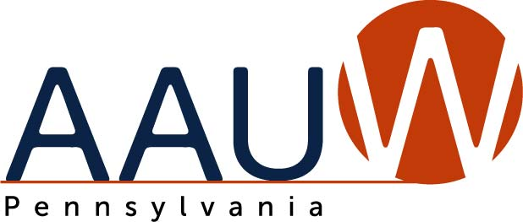

Program Fall 2022
August
Date: Thurs., Aug. 25th 7:00pm-8:00pm
Format: Zoom webinar
Title: Pennsylvania Reproductive Rights after Dobbs
Description:
We have heard from members that you are looking for greater understanding of the ramifications of the Dobbs v. Jackson Women's Health Supreme Court decision for Pennsylvanians, of what happens next and what we should be doing. The legal landscape is rapidly evolving and it is difficult to make sense of it. Fortunately, we have a legal expert, Sue Frietsche, who will distill things for us.
This program will help branches understand the issues and communicate effectively on this highly charged subject. Reproductive freedom has been an AAUW policy principle since 1977. Please urge members and others to attend.
Sue J. Frietsche, a senior staff attorney and founder and director of the Women’s Law Project’s Western Pennsylvania office, will discuss a case before the Pennsylvania Supreme Court in which she represents abortion providers challenging the state’s ban on Medicaid funds covering abortion. The case is based on the idea that abortion access is a right inherent in the state constitution based on Pennsylvania’s Equal Rights Amendment, which says "equality of rights under the law" can't be denied based on sex. She will also discuss the recent law suit brought by Governor Wolf challenging the constitutional amendments included in SB106.
Frietsche was recently appointed as co-director of the Women’s Law Project, a public interest law center in Pennsylvania devoted to advancing and defending the rights of women, girls, and LGBTQ+ people in Pennsylvania and beyond. Since joining the Law Project staff in 1992, she has litigated, lobbied, and organized on behalf of low-income women, domestic violence survivors, reproductive health care providers and their patients, teenage women needing confidential abortions, custodial parents owed child support, lesbian and gay parents, incarcerated women, and pregnant women excluded from substance abuse treatment.
The Women’s Law Project received the 2016 AAUW Pennsylvania’s Gateway to Equity Award.

